**TRAINING MODEL FOR THE NCS PLAYERS AND THE TECHNICAL BENCH ON SAVINGS BY THE JJF**

**SAVINGS AND RESOURCE MOBILIZATION**.

*Objectives of the model.*

* Inculcate the savings culture among our members.
* Provide a suitable savings channel to the members to enable them build up their savings for future purpose.

*What is savings*

* Money kept aside for use in a ‘rainy day.
* Amount of money assigned to future consumption .
* The difference between one’s income and consumption.
* Investment in land, gold, premium shares (that do not just depreciate), premium bonds, Valued Assets (including, land, goats, sheep, cows, chicken), etc.
* Savings is gradual where you put in your money in a safe and convenient place in small amounts over a period. until it builds up to the amount you want.

Why do, people save,

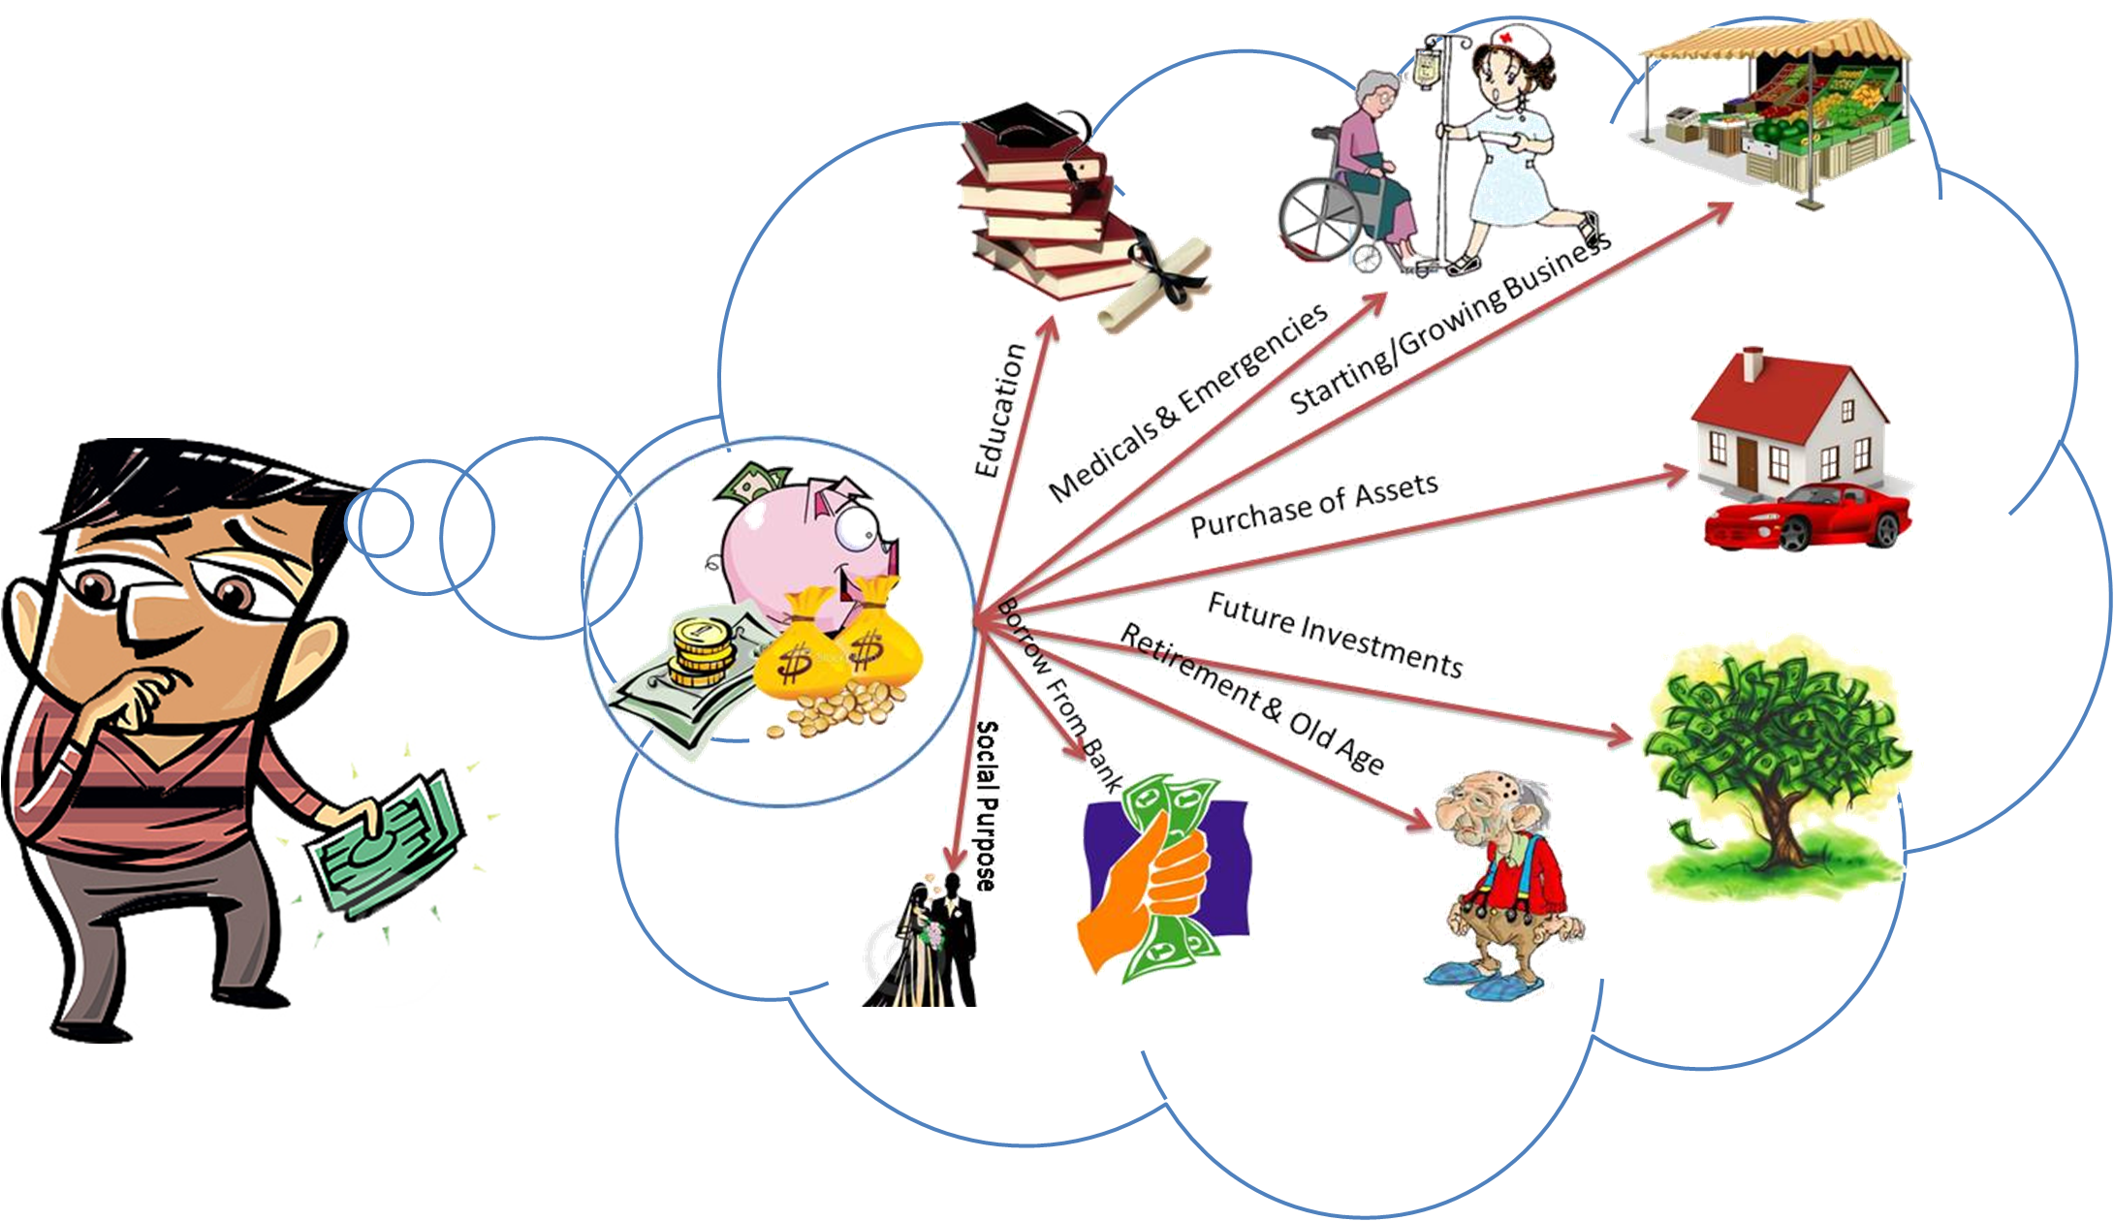

FACTORS THAT DETERMINE THE ABILITY TO SAVE

* Earnings (Income).
* consumption habits.
* socio-cultural obligations.
* Social influence.
* goals and ambitions; and
* surrounding a saver’s economic environment.

SAVING PROCESS



**PILLARS OF SAVINGS**

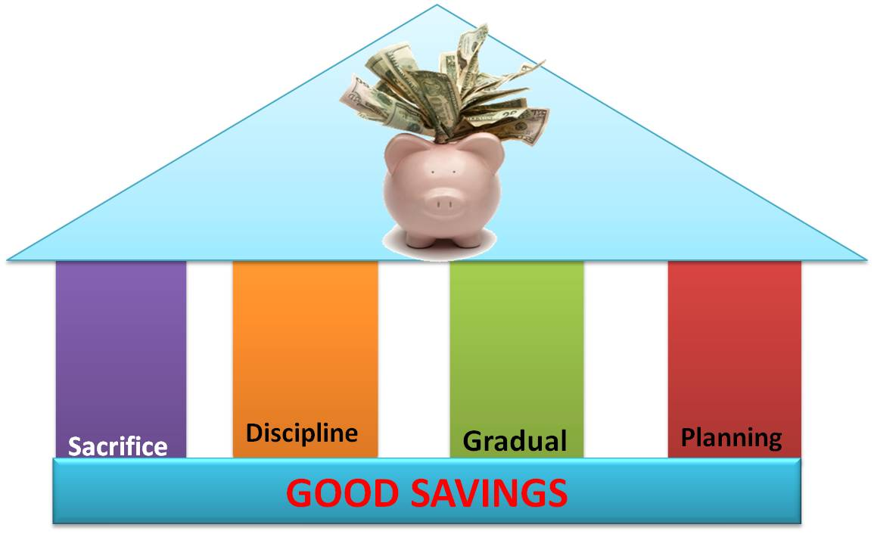

BENEFITS OF SAVINGS

* Create ability to invest in Productive Assets.
* Cushion against risks and financial shocks.
* Create peace of mind.
* Provide monetary safety net.
* Facilitate accumulation of wealth.
* To earn income in case of savings investments.
* To increase life’s options.
* Provide collateral to borrowing a loan.

SAVINGS CHANNELS

Formal.

* Banks (Commercial).
* Non-Bank Financial Institutions.
* Public Service Bodies/Programmes.
* Savings and Credit Cooperatives (SACCO’s).
* Regulated Deposit Taking Micro Finance Institutions (MFI).

Informal.

* Saving in kind.
* Saving in cash at home (home /piggy banks).
* Saving in cash with others.
* Collective savings.
* Table banking.
* Merry-go-round.
* C.B. O’s.
* Shop Keepers.
* Mobile phones banking.

**CHALLENGES OF SAVINGS**

* Lack of proper savings channels.
* Economic conditions.
* Culture and perception.
* Inconsistent in savings due to commitments.
* Minimal returns hence no motivation to save.
* Lack of sufficient information about savings.
* Demographic conditions (distance).
* Debts (over in debt.

HABBITS THAT HINDERS SAVINGS

* Living beyond your means.
* Bad life habits: - alcoholism.
* Being too over generous.
* Lack of planning or poor planning(budgeting).
* Impulse purchases (Buying without a plan or budget.
* Buying expensive items where else you can get the same items for a cheaper price.
* Buying excess: - buying extra items, yet you have similar items or items that can substitute them.
* Having a monkey hand (Raid the savings): -always opening the savings piggy or withdrawing from the account to access the money without prior plan.

|  |  |
| --- | --- |
| BARRIERS TO SAVINGS | SOLUTIONS |
| High living cost | Practice delayed gratification |
| Dreaded debts | Live within your means |
| Life unexpected circumstances | Set realistic goals and cater for emergencies |
| Impulse buying | Always work within your budgets |
| Poor planning | Change your thinking |
| Low income | Put in place saving plan |
| Lack of information | Attending trainings and semminars |

TIPS FOR SAVINGS

* Develop a culture to be saving.
* Discipline: - do not withdraw your money when you have not achieved your objective.
* Take account and record every savings you withdraw to enable you have financial plan.
* Always budget; have specified figures for your project.
* Cut down your expenses, for example if you use expensive means of transport go for cheaper means, if it is near home, some days you can sacrifice and walk home.
* Cut down or eliminate the unnecessary expenses.
* Shops for bargains; while shopping go for items that are on sale or discount prices. You make a lot of savings on the discounted items.
* Do not put your eggs in one basket: - Spread your savings in different savings channels to spread your risk.
* Patience and Hard Work: - you have to be patient and work hard to wait and build up your savings.
* Get Yourself Financial Education: - learn more about savings and also go further in understanding investment.
* keep on watering your savings; keep on saving and shower your savings with more money and the investment will grow and bear good fruits.

**XTICS OF SAVING GOALS**

* specific- what are you saving for
* measurable- how much are you saving
* attainable- are you able to raise the amount required at the set period
* realistic- are your goals achievable
* time bound- when will you reach your goal

EXPECTED OUTCOME

* Enhanced financial planning skills Savings knowledge and culture among members.
* Increased savings by members.
* Ability to pool resources for joint investment.
* Enhanced group cohesion arising and ability .