BUDGETING

BUDGETING

WHAT IS A BUDGET
- “A budget” also known as financial planning
  - is a plan that lays out what you will do with your money.”
  - A budget is a summary of estimated income and how it will be spent over a defined period
  - is a fairly simple tool that anyone, rich or poor, can use to manage money. serves as a master plan for the future.
  - a road map that can help entrepreneurs to realize their dreams.
- Making a budget will help you allocate your resources to meet multiple goals.

COMPONENTS OF A BUDGET
- Sources and amount of income
- Total planned income
- Types of expenditure, including enterprise and household expenses
- Amount of expenditure
- Total planned expenditures
- Total savings

WAYS TO IMPROVE A BUDGET
- List all income sources
- List all expenses
- Plan ahead to prevent spending more than your income
- Save surpluses to meet future expenses when income is low

DEBT MANAGEMENT
- A debt is an amount of money, goods or services borrowed from one party to another
- Debt can also be defined as money borrowed from someone else for temporary use and repayable after a defined period of time to the owner

WHY PEOPLE BORROW
- To invest & Expand Business
- To respond to an unexpected emergency e.g. sickness
- To consume
- To purchase(assets) an item for which they do not have enough money

BENEFITS OF BORROWING
- Access to lump sum amount sufficient to meet financial obligation
- Quick access to money to meet financial needs
- Promote growth and development of enterprises
- Promote financial discipline to the borrower
- Encourage borrowers to work smart and improve income
- Provide opportunities for example borrowing to buy land or other assets
- Facilitate borrowers to meet social obligation such as dowry and weddings
- Access to loan facilities help individual improve their livelihood, social status and earn social recognition in the society

FACTORS TO CONSIDER BEFORE BORROWING
- Cost of borrowing-That is interest rates and other related costs e.g. loan application and processing fee, insurance, valuation fee etc.
- Ability to pay the loan- your cash flow-The sources of income and/or savings you have to make those payments
- Purpose of the loan-( why are you borrowing
- Availability of collateral to secure the loan where required
- Emerging opportunities both enterprise and personal e.g. To buy assets on auction like land, furniture etc

WHEN YOU SHOULD NOT BORROW
- When you have no clear purpose why you are borrowing
- When you have not planned to borrow
- When the cost of borrowing is too high than the benefits you are going to gain from the use of money.
- If the loan will strain your financial flow (cash flow)
- When not sure of your cash flow (ability to pay)

CHALLENGES OF BORROWING
- Loan put you in a commitment which you must honor and if you fail legal action can be taken against you and even loss of property.
- A loan has costs tied to it; interest rates, processing fees, penalties and fines all these are born by the borrower.
- Uncertainty: situations beyond you may happen e.g. sickness death which may interfere with your ability to pay.

SIGNS OF DEBT GETTING OUT OF CONTROL
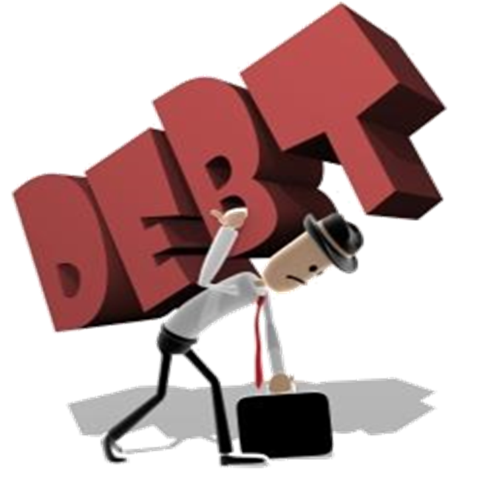
- Using credit to purchase things you once bought with cash
- Getting loans or extensions to pay your debts
- Using savings to repay loans
- Using credit for living expenses

DEBT MANAGEMENT
- Debt Management is a unique strategy developed to help a debtor manage their debt
- Debt Management also be defined as any strategy that helps a debtor to repay or otherwise handle their debt better

- Reactive Borrowing—do not have a plan for when cash will be needed; do not know exactly when there will be a shortfall.
Example: I am desperate to get any loan today at any cost because I have to pay my rent, otherwise we will get kicked out of our house.
- Borrowing without knowledge of the cost of borrowing from different sources—do not research credit options; take out a loan without asking questions about the loan because of a lack of understanding about loan terms.
Example: I was afraid to ask details about the loan because I just do not understand loan terms; it is intimidating. Afterwards, I found out that the interest rate is much higher than in other places.
- Over-commitment to debt—too many loans; excessive loan-to-income ratio; cannot sustain loan payments; get new loans from different sources to pay off the old loans.
Example: I had to get a loan from the local pawnshop in order to pay back my group loan.
- Borrowing to meet recurrent and life-cycle needs—lack of budgeting; no plan for cutting back on expenses to fit current income.
Example: I just realized I do not have enough money this month. I will need to borrow some money to pay for my utilities

